Experiment-08
Execute and display the results for the following Nmap service version and OS
detection commands in Kali Linux operating systems:
i) detect the version of services running
ii) aggressive scan
iii) detect operating system of the target
Aim: To execute and study the to detect the version of services running , aggressive scan,and detect operating system of the target commands in the Kali Linux operating system and observe their outputs.
Description:
detect the version of services running:
-sV command: Used to detect the versions of services running on the target system.
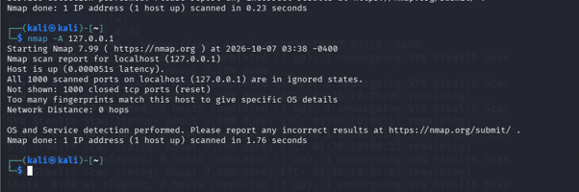
-A command: Used to perform an aggressive scan and gather detailed information about the target.
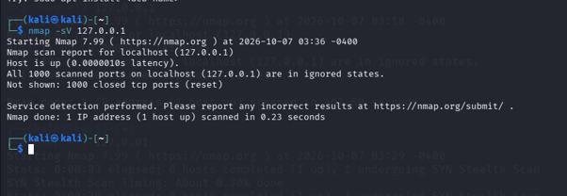
-O command: Used to detect the operating system of the target system.
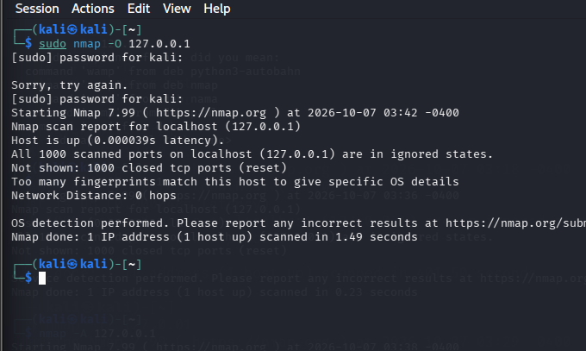

RESULT : we successfully executed and their outputs were observed in the Kali Linux operating system.

